ABOUT THE APP

This application determines if an infestation of sugarcane aphid in sorghum should be treated. Please select a treatment threshold based on your crop’s expected yield potential, potential grain price, and cost of control. Sample the field by examining sets of 2-leaf samples for each plant. The app will tell you if a field should be treated, or should not be treated.

INFORMATION

Please contact your local Extension Educator, Agriculture for information related to your sorghum production needs.

Extension Specialist Contact Details

Tom Royer- Extension Entomologist, IPM.

Phone: 405-744-9406

tom.royer@okstate.edu

HELPFUL LINKS

>><https://extension.okstate.edu/fact-sheets/management-of-insect-and-mite-pests-in-sorghum.html#sugarcane-aphid>

>><https://extension.okstate.edu/county/index.html>

DEVELOPMENT TEAM

This App was developed with financial support provided by the U.S. Department of Agriculture National Institute of Food and Agriculture's Crop Protection and Pest Management Applied Research and Development Program (grant no. 2015-7006-24259/project accession no. 1007751 and the Extension Implementation Program (grant no. 2017-7006-27282/project accession no. 1014126). Data was contributed by

Developers: Aman Masipeddi (Programmer), Tom A. Royer (Extension Entomologist) and Brian Arnall (Oklahoma State University). Contributors: Jessica Lindenmayer (Trécé Incorporated), Kristopher Giles (Oklahoma State University) , Norman C. Elliott (USDA ARS), Allen Knutson (Texas A&M Agrilife Research and Extension), Robert Bowling (Texas A&M Agrilife Research and Extension) Nicholas J. Seiter (University of Arkansas Research and Extension), Brian McCornack (Kansas State University), Sebe A. Brown (Louisiana State University).

DIRECTIONS

This application will help determine if a sorghum field infested with sugarcane aphid should be treated with an insecticide, based on an economic (treatment) threshold. The user selects a treatment threshold based on the crop’s yield potential, potential grain price, and cost of control. The user examines sets of 2-leaf samples per plant and estimates infested plants.

Collect samples from randomly selected plants that are spaced at least 20 feet apart. One sample consists of 2 fully expanded leaves that have 90% green leaf area: one from the top and one from the bottom of a plant. The two-leaf sample must have more than 50 aphids combined to be considered infested. The first example shows a leaf containing ca. 25 aphids within the yellow circle (ca. 40 aphids total). The second photo shows one leaf with ca. 50 aphids within the white circle (ca. more than 200 total). If the threshold is exceeded, the app will say that the field needs to be treated with an insecticide or not treated.

Approximately 25 aphids within the yellow circle.

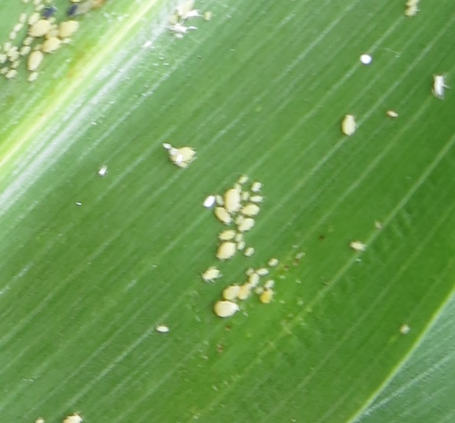

Approximately 50 aphids within the white circle.

